Fiber Optic

🌐 What Are Fiber Optic Cables?
# Source: AI Source: Provided by: [Data Path: Persons Table -> ID Column: 1, Name_En Column: Motasem Essam] -> From: [ChatGPT] on [12/18/2025]
Fiber optic cables are high-speed data transmission cables that use light signals to carry data through thin strands of glass or plastic fibers. They are designed for very high bandwidth, long distances, and minimal signal loss — making them ideal for modern backbone networks, internet infrastructure, and data centers.

Fiber Optic Image
# Source: ScreenShots Source: Provided by: [Persons Table -> ID Column: 1, Name_En Column: Motasem Essam] -> Tool: [Lightshot Program] -> From [Site: Google Search: Images: Fiber Optic] on [12/18/2025]
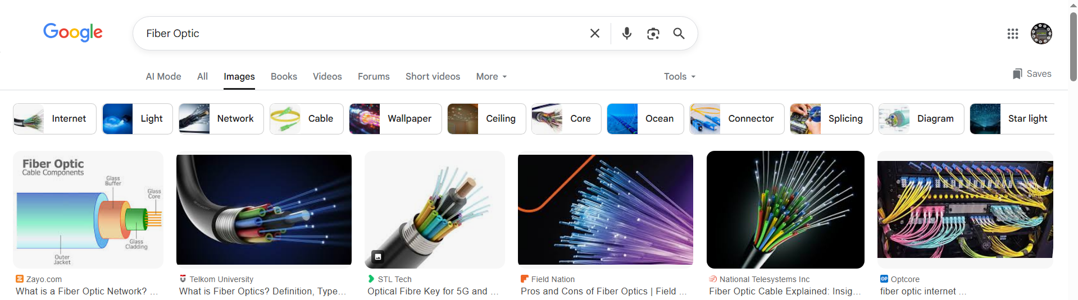

📦 Belongs to:
# Source: AI Source: Provided by: [Data Path: Persons Table -> ID Column: 1, Name_En Column: Motasem Essam] -> From: [ChatGPT] on [12/18/2025]
✅ Types of Network Cables
Specifically under wired (optical-based) transmission media.

🧠 Key Features
# Source: AI Source: Provided by: [Data Path: Persons Table -> ID Column: 1, Name_En Column: Motasem Essam] -> From: [ChatGPT] on [12/18/2025]
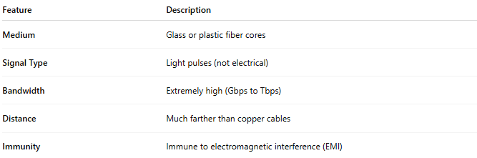

Feature | Description
Medium | Glass or plastic fiber cores
Signal Type | Light pulses (not electrical)
Bandwidth | Extremely high (Gbps to Tbps)
Distance | Much farther than copper cables
Immunity | Immune to electromagnetic interference (EMI)

🧾 Types of Fiber Optic Cables

🔹 Single-Mode Fiber (SMF)
# Source: AI Source: Provided by: [Data Path: Persons Table -> ID Column: 1, Name_En Column: Motasem Essam] -> From: [ChatGPT] on [12/18/2025]
- Core Diameter: ~8–10 microns
- Light Type: Laser
- Distance: Up to 100+ km
- Use Case: Long-distance connections (ISP backbones, WANs)

🔸 Multi-Mode Fiber (MMF)
# Source: AI Source: Provided by: [Data Path: Persons Table -> ID Column: 1, Name_En Column: Motasem Essam] -> From: [ChatGPT] on [12/18/2025]
- Core Diameter: ~50–62.5 microns
- Light Type: LED
- Distance: Up to 2 km (typically <550 m at high speeds)
- Use Case: Short-distance (LANs, data centers)

🔌 Common Fiber Connectors
# Source: AI Source: Provided by: [Data Path: Persons Table -> ID Column: 1, Name_En Column: Motasem Essam] -> From: [ChatGPT] on [12/18/2025]
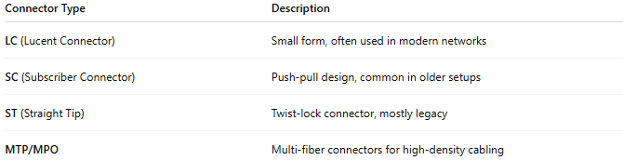

Connector Type | Description
LC (Lucent Connector) | Small form, often used in modern networks
SC (Subscriber Connector) | Push-pull design, common in older setups
ST (Straight Tip) | Twist-lock connector, mostly legacy
MTP/MPO | Multi-fiber connectors for high-density cabling

✅ Advantages
# Source: AI Source: Provided by: [Data Path: Persons Table -> ID Column: 1, Name_En Column: Motasem Essam] -> From: [ChatGPT] on [12/18/2025]
- ⚡ Ultra-fast speeds (1 Gbps to 400 Gbps+)
- 🧠 No EMI or crosstalk
- 📏 Very long distances without signal loss
- 🔒 More secure — harder to tap without detection
- 🌐 Ideal for backbones, ISP links, data centers, long-haul networks

❌ Disadvantages
# Source: AI Source: Provided by: [Data Path: Persons Table -> ID Column: 1, Name_En Column: Motasem Essam] -> From: [ChatGPT] on [12/18/2025]
- 💰 More expensive than copper cables
- 🔧 Requires special tools and skills to install or terminate
- ❌ Fragile — glass fiber is delicate if bent or mishandled

📌 Summary
# Source: AI Source: Provided by: [Data Path: Persons Table -> ID Column: 1, Name_En Column: Motasem Essam] -> From: [ChatGPT] on [12/18/2025]
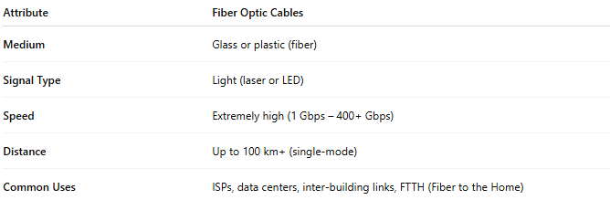

Attribute | Fiber Optic Cables
Medium | Glass or plastic (fiber)
Signal Type | Light (laser or LED)
Speed | Extremely high (1 Gbps – 400+ Gbps)
Distance | Up to 100 km+ (single-mode)
Common Uses | ISPs, data centers, inter-building links, FTTH (Fiber to the Home)

